**MEETING MINUTES: SUMO DIGITAL GROUP PROJECT – Discord meeting**

Date of Meeting : 6th March 2019

Time of Meeting : 18:10

Attendees:- Jordan, Ash, Macaulay, Len

Apologies from:-

**Item One:- Postmortem of previous week**

**What went well : be specific**

The UI in our game has been started and we no have a health bar and ammo counter, the wheel rotation just needs to be started.

The camera movement is also now working

The level design assets and scene for our first level has been successfully made (it is due to change if needed after playtesting i.e. scaled bigger)

**What went badly : be specific**

There are currently 2 bugs in the game which is the bullet firing in the wrong direction and the weapon switching bug which stops the weapons from firing.

The UI coding needs to be finished

The game menus designs were not logged and not finished so they have been moved to the next sprint – this is due to hardware malfunction which has erased previous designs

Weapon assets need to be made and are moving to the next sprint

There was also poor preparation in getting the video sorted for the presentation

**Feedback Recieved : On any aspect of the game, either from tutors, or playtesters etc.**

In our presentation, the feedback we received was to focus on how to gradually make the levels more difficult with the Auto shoot and Auto weapon switch in mind. This was from Rob.

Harley wanted to know how were going to go about setting up the UI in our game.

Alex also made a recommendation that when it comes to the weapon wheel we should have bullets available and show the time between shots and the time the player has left with the weapon they have in their hand:

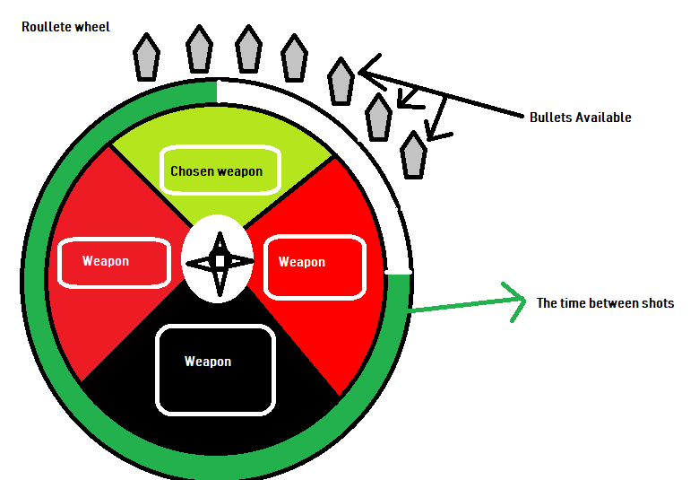

**Individual work completed:-**

Person 1 Jordan – Camera movement is now working and is currently working on bug fixing   
Person 2 Ash – Has started to code the scripts for the UI and has discussed them with Jordan as to the what other UI there is left to do  
Person 3 Macaulay – Has started the game menus designs but didn’t log them and it’s being moved to the next sprint.   
Person 4 Len – Has created the level design scene in Unity along with the assets in the first level. The first level of our game is now complete.

**Item 2:- Overall Aim of the current weeks sprint (What will the product look like by the end of the sprint. Be Specific. We will have a .....That does X and Y**

Our Aim for this current sprint is for the programming; to just focus on bug fixing as we have 2 bugs that seem to be a blocker for the rest of the tasks and they are important to fix as they are stopping us from being able to start play testing.

For the design side, game menu buttons need to be designed and we need more weapon assets made for the game. The 2nd and the 3rd levels can now be started and worked on along with creating character and enemy animations.

**Tasks for the current week:-**

You need to be absolutely clear as a team that individual participants understand the tasks they are being asked to complete and have estimated how long it will take them to finish. No more than 6 hours per person per week, 3 hours in lab-based work and 3 remotely delivered.

Person 1 tasks – Jordan – Is working on the bullet bug where it shoots in the wrong direction   
Person 2 tasks – Ash - Is working on the weapon switching bug which causes weapons to stop shooting  
Person 3 tasks – Macaulay – Is focusing on designing game menu buttons and making 5 more weapon assets   
Person 4 tasks – Len – Is focusing on starting the 2nd level scene design and animating the character and enemies.

(These tasks to be uploaded and tracked on JIRA)

**Item 3:- Any Other Business.**

The presentation went well despite not having a video and for Jordan not being there. We still received good feedback and it has provided us with good suggestions on making our UI better and making our game difficulty increase in the focus of auto shooting and auto weapon switching.

It has also given us a chance to properly talk as a group to sort out little issues that were not talked about before.

After the presentation, I decided to talk to Jordan about our project management roles and to understand why he couldn’t join us for the pitch. After our discussion, everything is now cleared up and we have decided that the programmers now only set 1 or 2 tasks on Jira each week as bugs come up and remaining tasks are left on to do and sent to the next sprint which are bad working habits. We also discussed that over scoping is something we don’t want to do and to always communicate if something doesn’t seem right or if a member is feeling overwhelmed with their tasks.

We have decided to make our decisions effective immediately so that everyone in our group clearly knows what tasks they have to do each week and to understand the same goal we are all reaching for and to understand, most importantly, how to work in a group together.

Meeting Ended :- 18:32

Minute Taker:- Len